CECS 225

Lab 4

Eugene Paul Mesina



* **Section 1:** Adder_32
* 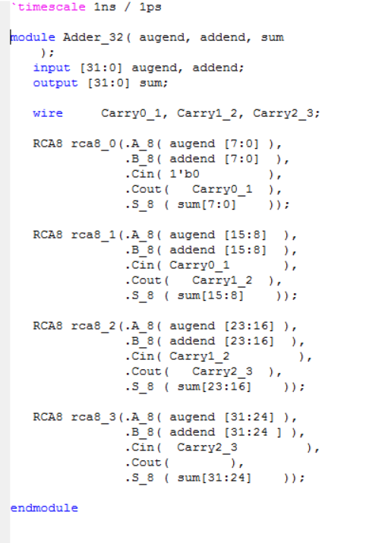
* **Section 2:** RTL Schematic of Adder_32
* 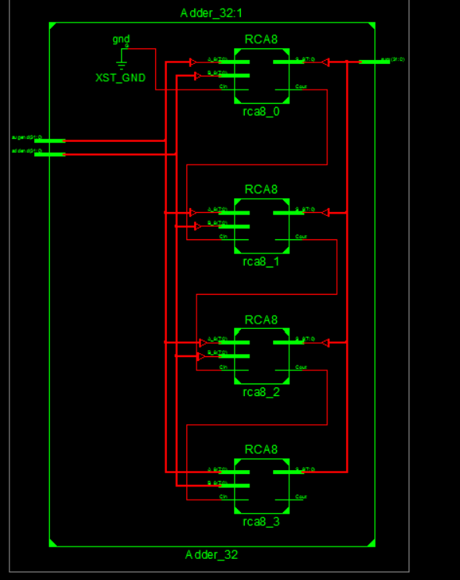
* **Section 3:** ALU
* 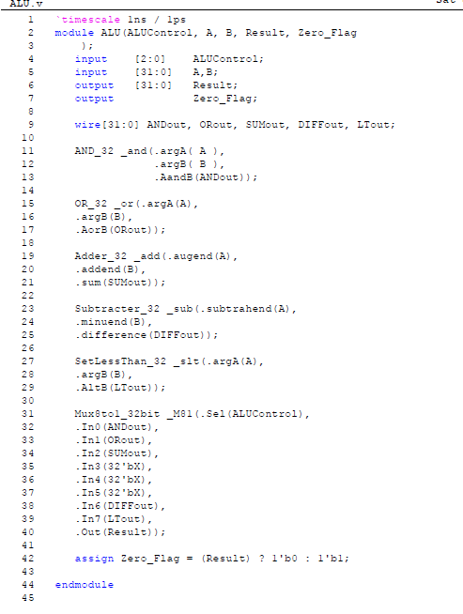
* **Section 4:** ALU_Tester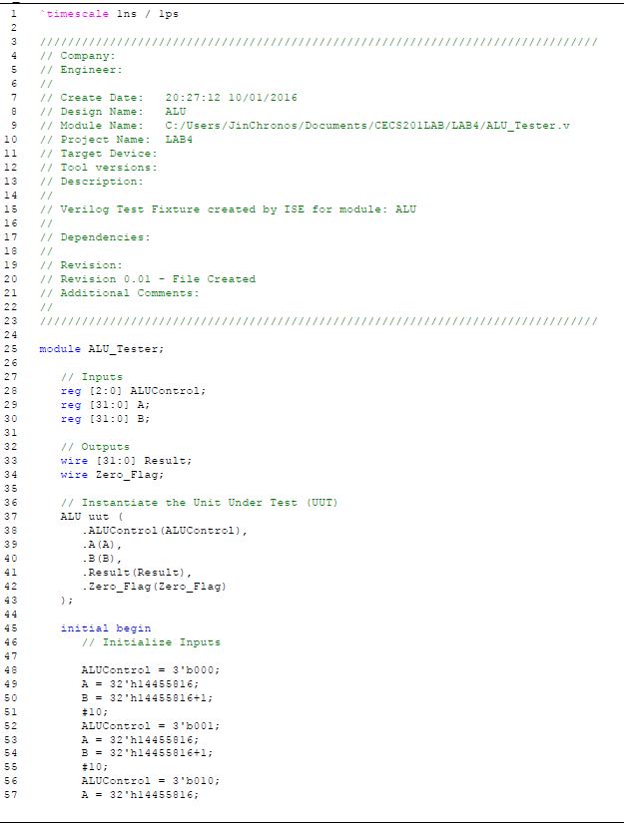
* **Section 5:** ALU Test Results
* 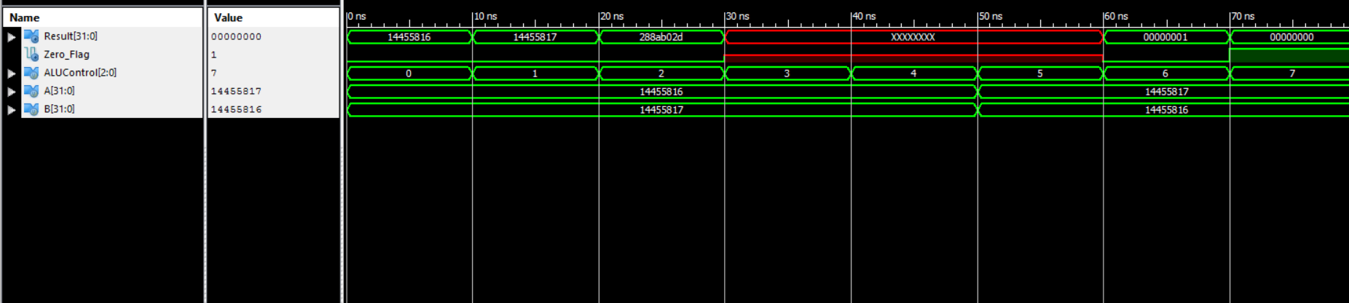
* **Section 6:** RTL Schematics
* 